**Unit II: IMAGE ENHANCEMENT**

Image enhancement is a set of techniques used to improve the visual quality or perception of an image. The goal of image enhancement is to make an image more suitable for specific tasks like human observation, computer analysis, or feature extraction. There are various methods and algorithms employed in image enhancement, and they can be broadly categorized into two types: spatial domain and frequency domain methods.

**Spatial Domain Image Enhancement**:

Spatial domain techniques operate directly on the pixel values of the image. They involve modifying pixel values based on their neighboring pixels to enhance certain image characteristics.

**a. Histogram Equalization**: This method redistributes the intensity levels in an image's histogram to improve contrast. It stretches the pixel intensity range to cover the full available range.

**b. Contrast Stretching:** Similar to histogram equalization, contrast stretching linearly expands the pixel intensity range to improve contrast.

**c. Gamma Correction:** This method adjusts the gamma value to correct image brightness and contrast, particularly useful for low-light or high-light conditions.

**d. Spatial Filtering:** Spatial filters, such as the mean filter, median filter, and Gaussian filter, are used to smooth an image, reduce noise, or sharpen edges.

**e. Histogram Specification**: This method matches the histogram of an image to that of a reference image, resulting in similar intensity distributions.

**Frequency Domain Image Enhancement:**

Frequency domain techniques work by transforming the image into the frequency domain using techniques like the Fast Fourier Transform (FFT). Enhancements are performed in the frequency domain, and the result is then transformed back to the spatial domain.

**a. Low-Pass Filtering:** Low-pass filters remove high-frequency components, reducing noise and blurring the image.

**b. High-Pass Filtering:** High-pass filters enhance the high-frequency components, emphasizing edges and details.

**c. Homomorphic Filtering:** It is used to correct non-uniform lighting conditions and improve the visibility of details in the image.

**d. Wiener Filtering:** Wiener filtering is a statistical method used to deblur images corrupted by additive noise.

**Point & Histogram processing**

Point processing and histogram processing are two fundamental techniques used in image enhancement. They both operate in the spatial domain and involve manipulating the pixel values of an image to improve its visual quality and extract relevant information.

**Point Processing:**

Point processing, also known as pixel-wise processing, involves transforming individual pixel values in the image independently without considering the neighboring pixels. The transformation is usually defined by a simple mathematical function, and each pixel's new value depends solely on its original intensity value.

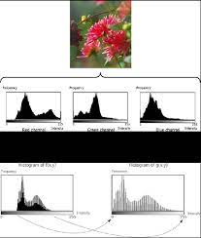

Common point processing functions include:

**Contrast Stretching:** Linearly scales the pixel values to expand the intensity range and enhance contrast.

**Gamma Correction**: Applies a power-law function to adjust the brightness and contrast of the image.

**Thresholding**: Converts pixel values above or below a certain threshold to white or black, respectively, to create binary images.

Point processing is simple and efficient but may not be able to handle complex enhancement tasks that require consideration of spatial relationships between pixels.

**Histogram Processing:**

Histogram processing involves manipulating the histogram of an image to redistribute the pixel intensities. The histogram represents the frequency distribution of different intensity levels in the image. By modifying the histogram, we can effectively change the overall contrast and brightness of the image.

Common histogram processing techniques include:

**Histogram Equalization:** Redistributes the histogram such that the cumulative distribution function is linearized, resulting in an image with improved contrast.

**Histogram Matching/Specification:** Adjusts the histogram to match a specified target histogram, often derived from another reference image. It is used to standardize the intensity distribution or match images to a desired reference.

Histogram processing is particularly useful when an image has low contrast or limited intensity levels. It can enhance the visual appearance and highlight important features in the image.

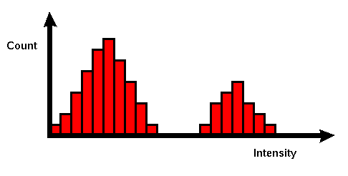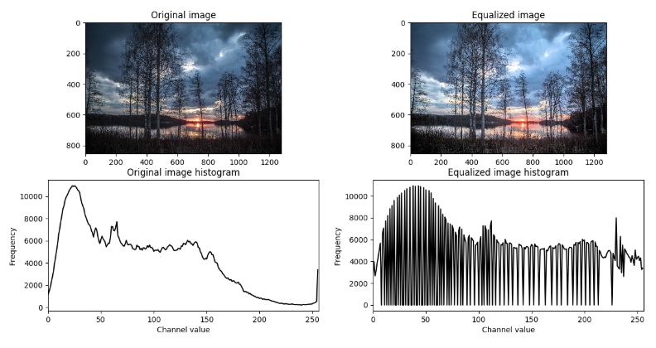

**Combining Point and Histogram Processing:**

Often, point processing and histogram processing techniques are used in combination to achieve more sophisticated image enhancements. For instance, we can first apply contrast stretching using point processing to improve the dynamic range of the image. Next, we may apply histogram equalization to further enhance the contrast and bring out the details in different parts of the image.

Image enhancement is a flexible area, and the choice of specific techniques depends on the image's characteristics and the specific requirements of the application. A combination of point processing and histogram processing can lead to powerful enhancements, but it's essential to carefully adjust parameters and consider the impact on the overall image quality.

**Fundamentals of Spatial filtering**

Spatial filtering is a fundamental technique used in image processing to enhance or modify an image by performing operations directly on the pixel values of the image in its spatial domain. The spatial filter is a small matrix, also known as a kernel or mask, that slides over the entire image, and at each position, it performs a local operation based on the pixel values and the corresponding kernel elements. The purpose of spatial filtering is to highlight or suppress certain image features, such as edges, textures, or noise, to improve the visual quality or extract useful information from the image.

Here are the key fundamentals of spatial filtering:

1. **Convolution:**Spatial filtering is typically achieved through convolution. Convolution is a mathematical operation that involves overlaying the kernel on each pixel of the image and taking the weighted sum of the pixel intensities covered by the kernel. The kernel's values act as weights, determining how much influence each pixel has on the final output.
2. **Kernel Size:**The size of the kernel determines the size of the local neighborhood over which the filter operates. Commonly used kernel sizes are 3x3, 5x5, and 7x7, although larger kernels can also be employed for specific purposes.
3. **Filter Types:**Spatial filters can be broadly categorized into two types based on their effects on the image:

**a. Low-Pass Filters:** Low-pass filters smooth an image by reducing high-frequency components, effectively blurring the image. They are used to remove noise and create a more visually pleasing appearance.

**b. High-Pass Filters:** High-pass filters enhance the edges and fine details in an image by amplifying high-frequency components and suppressing low-frequency components. They are useful for edge detection and feature extraction.

1. **Common Spatial Filters:**Some common spatial filters include:

**a. Box Filter (Average Filter):** All elements in the kernel have equal weights, and the convolution operation calculates the average intensity of the pixel neighborhood. It helps in smoothing the image.

**b. Gaussian Filter:** The Gaussian filter uses a kernel based on the Gaussian distribution. It applies a weighted average to the pixel neighborhood, with higher weights assigned to closer pixels. It is widely used for noise reduction and image smoothing.

**c. Sobel Filter:** Sobel filters are used for edge detection. They calculate the gradient of the image to emphasize edges in the horizontal and vertical directions.

**d. Laplacian Filter:** The Laplacian filter highlights regions with rapid intensity changes and enhances edges and fine details.

1. **Handling Image Borders:** When applying spatial filters near the edges of the image, there is a challenge of undefined pixel values outside the image boundary. Different approaches can be used to handle this, such as zero-padding, reflecting the pixels, or using mirrored pixels.

Spatial filtering is an essential tool in image processing and is widely used in various applications, including image enhancement, noise reduction, edge detection, and feature extraction.

**Smoothing spatial filters**

Smoothing spatial filters, also known as low-pass filters, are used to reduce noise and blur an image by suppressing high-frequency components while preserving low-frequency components. These filters are particularly useful for creating a more visually pleasing appearance and removing unwanted details or noise from an image. Here are some commonly used smoothing spatial filters:

1. **Box Filter (Average Filter):** The box filter, also known as the average filter, applies a simple averaging operation to the pixel neighborhood covered by the kernel. Each pixel in the output image is the average of the pixel intensities within the kernel window. This filter effectively blurs the image and reduces noise.
2. **Gaussian Filter:** The Gaussian filter applies a weighted average to the pixel neighborhood, where the weights are determined by a Gaussian distribution. It is more effective than the average filter for smoothing while preserving the image's important features. The Gaussian filter is widely used for noise reduction and image smoothing.
3. **Median Filter:** The median filter replaces the pixel value at the center of the kernel with the median value of the pixel intensities within the kernel window. This filter is excellent for removing salt-and-pepper noise without blurring the edges or fine details in the image.
4. **Bilateral Filter:** The bilateral filter is a non-linear smoothing filter that takes into account both spatial and intensity differences between pixels. It preserves edges and fine details while reducing noise. The filter uses two Gaussian functions: one for spatial distance and another for intensity difference.
5. **Mean Shift Filter:** The mean shift filter is an adaptive smoothing technique that can effectively preserve edges while reducing noise. It iteratively shifts each pixel towards the mean of its neighborhood in both spatial and color domains.
6. **Anisotropic Diffusion:** Anisotropic diffusion is an iterative diffusion process that selectively diffuses information across the image, emphasizing the diffusion along edges and preserving sharp features. This filter is useful for denoising while preserving important image structures.

The choice of the smoothing spatial filter depends on the specific application and the trade-off between noise reduction and preserving image details. Some filters are better suited for specific types of noise or image characteristics, so experimentation and parameter tuning are often necessary to achieve the desired smoothing effect.

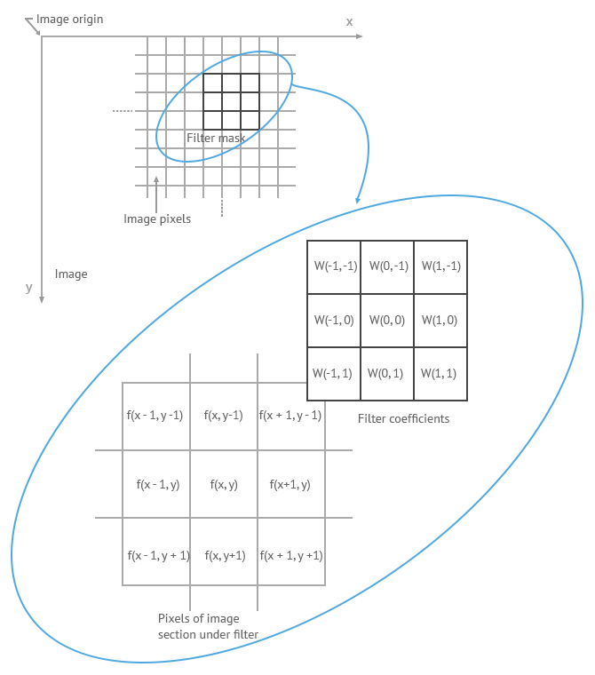

**Sharpening spatial filters**

Sharpening spatial filters, also known as high-pass filters, are used to enhance the edges and fine details in an image by amplifying high-frequency components while suppressing low-frequency components. These filters are particularly useful for improving image sharpness and highlighting important image features. Here are some commonly used sharpening spatial filters:

1. **Laplacian Filter:**

The Laplacian filter calculates the second derivative of the image to highlight regions with rapid intensity changes, such as edges and fine details. It enhances the high-frequency components in the image and can be used to sharpen the image. However, the Laplacian filter tends to amplify noise, so it is often combined with other filters or smoothing techniques.

1. **Unsharp Masking:**

Unsharp masking is a popular sharpening technique that involves subtracting a blurred version of the image from the original. The process is as follows:

a. Create a blurred version of the image using a low-pass filter (e.g., Gaussian filter).

b. Subtract the blurred image from the original image.

c. Add the result back to the original image with an adjustable weight (contrast enhancement factor).

Unsharp masking enhances the edges and fine details while reducing the impact of noise, as the blurred image acts as a noise suppressor.

1. **High-boost Filtering:**

High-boost filtering is a generalized version of unsharp masking that allows more control over the sharpening effect. It enhances the high-frequency components while preserving the overall image brightness and contrast. The high-boost filter is defined as:

* sharpened_image = original_image + k * (original_image - blurred_image)

1. **Prewitt and Sobel Filters:**

Prewitt and Sobel filters are gradient-based filters used for edge detection. They calculate the gradient in both horizontal and vertical directions and then combine the magnitude of the gradients to obtain edge information. By emphasizing edges, these filters can effectively sharpen the image.

1. **Gradient Filters:**

Gradient filters, such as Roberts cross, Scharr, and Kirsh filters, are also used for edge detection. They calculate the gradient magnitude and direction, which can be used to highlight edges and sharp features in the image.

**Frequency domain methods:**

**Basics of filtering in frequency domain**

Frequency domain methods in image processing involve transforming the image from the spatial domain to the frequency domain using mathematical transformations like the Fast Fourier Transform (FFT) or Discrete Fourier Transform (DFT). Once in the frequency domain, filtering operations can be performed to enhance or modify specific frequency components of the image. After filtering, the image is transformed back to the spatial domain using the inverse Fourier transform to obtain the final processed image. Filtering in the frequency domain is particularly useful for tasks such as noise reduction, image sharpening, and feature extraction. Here are the basic steps involved in filtering in the frequency domain:

1. **Fourier Transform:** The first step is to apply the Fourier transform (either FFT or DFT) to convert the image from the spatial domain to the frequency domain. The Fourier transform decomposes the image into its constituent frequency components, representing how different spatial frequencies contribute to the image.
2. **Frequency Spectrum:** The result of the Fourier transform is a complex-valued matrix known as the frequency spectrum. It contains information about the magnitudes and phases of various frequency components present in the image.
3. **Frequency Filtering:** In the frequency domain, filtering involves modifying the frequency spectrum to emphasize or suppress certain frequency components. The filtering operation is usually performed by applying a filter kernel to the frequency spectrum. The filter kernel specifies the magnitude response for different frequencies, determining which frequencies are enhanced or attenuated.

**a. Low-Pass Filtering**: Low-pass filters allow low-frequency components to pass through while attenuating high-frequency components. They are used for noise reduction and smoothing. Examples of low-pass filters include the ideal low-pass filter, Gaussian low-pass filter, and Butterworth low-pass filter.

**b. High-Pass Filtering:** High-pass filters allow high-frequency components to pass through while attenuating low-frequency components. They are used for image sharpening and edge enhancement. Examples of high-pass filters include the ideal high-pass filter, Gaussian high-pass filter, and Butterworth high-pass filter.

**c. Band-Pass Filtering:** Band-pass filters allow a specific range of frequencies to pass through while attenuating frequencies outside this range. They are useful for isolating specific features or frequency bands in the image.

1. **Inverse Fourier Transform:**

After filtering, the modified frequency spectrum is transformed back to the spatial domain using the inverse Fourier transform. This process combines the filtered frequency components to reconstruct the final processed image.

**image smoothing**

Image smoothing, also known as image blurring or low-pass filtering, is a technique used to reduce noise and remove fine details from an image, resulting in a more visually pleasing and less noisy version of the image. Smoothing is achieved by suppressing high-frequency components while preserving low-frequency components in the image. This is typically done using low-pass filters in either the spatial domain or the frequency domain.

**Smoothing in the Spatial Domain:**

Spatial domain smoothing involves directly manipulating the pixel values of the image using a smoothing filter kernel. The filter kernel is applied to each pixel in the image, and the resulting pixel value is a weighted sum of the neighboring pixels within the kernel window.

Common spatial domain smoothing filters include:

1. **Box Filter (Average Filter):** Each pixel in the output image is the average of the pixel intensities within the kernel window. This filter effectively blurs the image and reduces noise.
2. **Gaussian Filter:** The Gaussian filter applies a weighted average to the pixel neighborhood, with the weights determined by a Gaussian distribution. It provides smoother results compared to the box filter and is widely used for noise reduction and image smoothing.
3. **Median Filter:** The median filter replaces the pixel value at the center of the kernel with the median value of the pixel intensities within the kernel window. It is effective for removing impulse noise (salt-and-pepper noise) while preserving edges and fine details.
4. **Bilateral Filter:** The bilateral filter is a non-linear smoothing filter that takes into account both spatial and intensity differences between pixels. It preserves edges and fine details while reducing noise. The filter uses two Gaussian functions: one for spatial distance and another for intensity difference.

**Smoothing in the Frequency Domain:** Frequency domain smoothing involves transforming the image from the spatial domain to the frequency domain using the Fourier transform. In the frequency domain, a low-pass filter is applied to suppress high-frequency components, and then the image is transformed back to the spatial domain using the inverse Fourier transform.

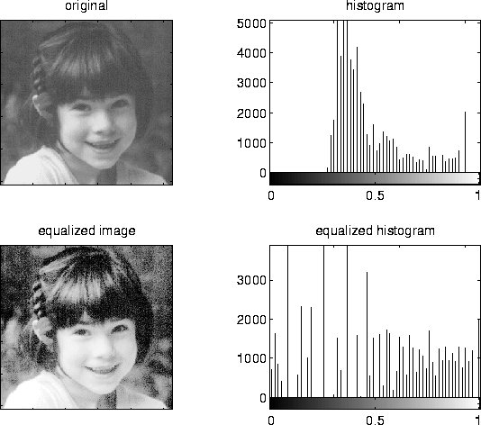

The frequency domain approach can be computationally more efficient for large images, especially when dealing with certain types of noise. However, it can introduce boundary artifacts due to the periodic nature of the Fourier transform. To address this issue, techniques like zero-padding and windowing are employed

**image sharpening**

Image sharpening is a technique used to enhance the edges and fine details in an image to make it visually clearer and more defined. Unlike image smoothing (which reduces noise and blurs the image), sharpening increases the contrast around edges and highlights important features. Image sharpening is achieved by applying a high-pass filter that amplifies high-frequency components while suppressing low-frequency components.

There are several methods for image sharpening, with some of the most commonly used techniques being:

**Laplacian Sharpening:**

The Laplacian sharpening is a classic method for image sharpening. It involves using the Laplacian filter, which highlights regions with rapid intensity changes (i.e., edges) in an image. The process is as follows:

a. Apply a Gaussian blur to the original image using a low-pass filter to remove noise and create a slightly blurred version of the image.

b. Calculate the Laplacian of the blurred image to obtain an edge map.

c. Add the edge map to the original image or combine them with the original image using a weight.

The Laplacian sharpening enhances edges and fine details, but it may also amplify noise, so it is often used in combination with noise reduction techniques.

**Unsharp Masking:**

Unsharp masking is a widely used sharpening technique that is based on the idea of subtracting a blurred version of the image from the original to obtain a mask representing the high-frequency components. The steps are as follows:

a. Create a blurred version of the original image using a low-pass filter (e.g., Gaussian filter).

b. Subtract the blurred image from the original image to obtain the unsharp mask.

c. Add the unsharp mask to the original image with an adjustable weight (contrast enhancement factor).

Unsharp masking enhances edges and fine details while reducing the impact of noise since the blurred image acts as a noise suppressor.

**High-boost Filtering:**

High-boost filtering is a generalized version of unsharp masking that allows more control over the sharpening effect. It enhances the high-frequency components while preserving the overall image brightness and contrast. The high-boost filter is defined as:

* sharpened_image = original_image + k * (original_image - blurred_image)

where 'k' is a user-defined constant that determines the degree of sharpening.

**Selective filtering**

Selective filtering, also known as adaptive filtering, is a type of image filtering technique where the filtering process is applied selectively or adaptively to different regions of the image based on certain criteria. Unlike traditional global filtering methods that treat the entire image uniformly, selective filtering allows for more localized and context-aware filtering, making it particularly useful for complex images with varying characteristics.

The goal of selective filtering is to retain important image features, such as edges and textures, while effectively suppressing noise and artifacts. This approach can improve the overall image quality and preserve image details, especially in regions where traditional filtering methods might lead to undesirable blurring or loss of information.

There are several ways to implement selective filtering, and some commonly used techniques include:

1. **Adaptive Smoothing:** In adaptive smoothing, the level of smoothing is adjusted based on the local image characteristics. For example, in areas with high noise or rapid intensity changes (edges), stronger smoothing may be applied to reduce noise or blur the regions. Conversely, in areas with low noise or relatively smooth gradients, less smoothing or no filtering may be applied to preserve image details.
2. **Edge-Preserving Filters:** Edge-preserving filters are designed to maintain sharp edges and fine details while reducing noise. These filters are particularly useful in scenarios where noise reduction is necessary, but preserving the image structure is crucial. Examples of edge-preserving filters include bilateral filter, guided filter, and anisotropic diffusion.
3. **Detail Enhancement:** Selective filtering can also be used to enhance fine details in an image while leaving other regions unchanged. This is useful for applications like image sharpening or emphasizing important features. Techniques such as unsharp masking and high-boost filtering fall into this category.
4. **Region-Based Filtering:** Region-based filtering involves dividing the image into distinct regions based on certain characteristics (e.g., texture, color, or intensity). Different filtering techniques or filter parameters can then be applied to each region based on its specific properties.
5. **Multi-Scale Filtering:** In multi-scale filtering, filtering is performed at multiple scales (different kernel sizes) to adapt to varying features and structures in the image. This approach is often used in applications like edge detection and feature extraction.